Ma feuille de route pour accéder aux métiers qui m’intéressent le plus :
Pour chaque métier que j’ai retenu je coche les domaines de formations qui correspondent (Onisep):
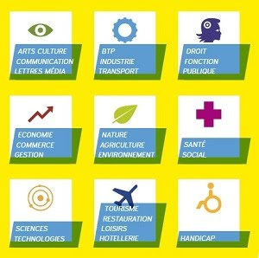

Je cherche sur le forum, les formations proposées en fonction des domaines retenus :
https://www.education.pf/forumpostbac
-------------------------------------------------------------------------------------------------------------------------------------------------------------------------------------------------------------------------------

Pour finir….. Je fais le point sur mes résultats scolaires :
Les 3 matières qui m’intéressent le plus au lycée :
………………………………………………………………………………………………….
Les 3 matières qui m’intéressent le moins au lycée :
………………………………………………………………………………………………….
Les 3 matières dans lesquelles je réussis le mieux au lycée :
………………………………………………………………………………………………….
Les 3 matières dans lesquelles je réussis le moins au lycée :
…………………………………………………………………………………………………..

Mes Notes….
-------------------------------------------------------------------------------------------------------------------------------------------------------------------------------------------------------------------------------------------------------------------------------------------------------------------------------------------------------------------------------------------------------------------------------------------------------------------------------------------------------------------------------------------------------------------------------------------------------------------------------------------------------------------------------------------------------------------------------------------------------------------------------------------------------------------------------------------------------------------------------------------------------------------------------------------------------------------------------------------------------------------------------------------------------------------------------------------------------------------------------------------------------------------------------------------------------------------------------------------------------------------------------------------------------------------------------------------------------------------------------------------------------------------------------------------------------------------------------------------------------------------------------------------------------------------------------------------------------------------------------------------------------------------------------------------------------------------------------------------------------------------------------------------------------------------------------------------------------------------------------------------------------------------------------------------------------------------------------------------------------------------------------------------------------------------------------------------------------------------------------------------------------------------------------------------------------------------------------------------------------------------------------------------------------------------------------------------------------------------------------------------------------------------------------------------------------------------------------------------------------------------------------------------------------------------------------------------------------------------------------------------------------------------------------------------------------------------------------------------------------------------------------------------------------------------------------------------------------------------------------------------------------------------------------------------------------------------------------------------------------------------------------------------------------------------------------------------------------------------------------------------------------------------------------------------------------------------------------------------------------------------------------------------------------------------------------------------------------------------------------------------------------------------------------------------------------------

